3-2-1 Bridge
Topic ______________________________

3 Words a. _______________________________ 3 Words a. ________________________________
b. _______________________________ b. ________________________________
c. _______________________________ c. ________________________________

2 Questions a. ______________________________________ 2 Questions a. _______________________________________
________________________________________ _________________________________________
b. ______________________________________ b. _______________________________________
________________________________________ _________________________________________

Simile/ ________________________________________ Simile/ _________________________________________
Metaphor ________________________________________ Metaphor _________________________________________
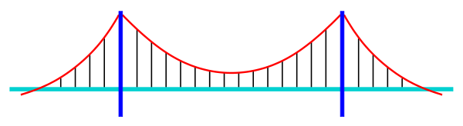
How has your thinking changed on the topic of _________________________________?

