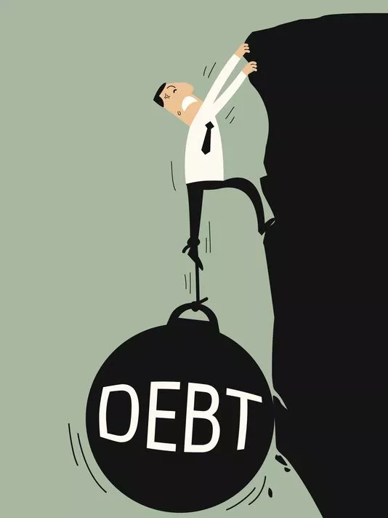
I. Balancing the Budget:

Balanced Budget -
Budget Surplus -
Budget Deficit -

II. Government Response to Debt/Deficit:
a. Government can _________________________________________________________
b. Governments can _________________________________________________________

III. Debt vs. Deficit:
a. Deficit -
b. Debt -

IV. Problems with National Debt:
a. If there is a large national debt

b. The government borrows ____________________________________________________
1. Bonds are

2. Government bonds are purchased

3.

4. If people are _________________________________________________________

c. The government must pay

