Demand - Key Terms
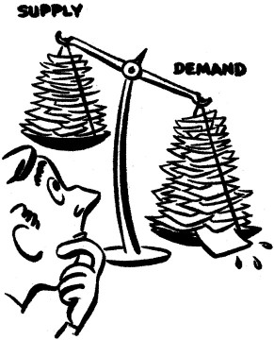
Directions: Define the term, give an example of the concepts, and create a symbol that you feel represents teach key term. (page 79) Be sure that your definitions are connected to the field of economics and not just general definitions. You will also have to use the Internet to locate some of the terms.
Term | Definition | Example | Symbol
Demand
Law of Demand
Substitution Effect
Demand Schedule

Demand Curve

