Demand Schedule for Lollipops
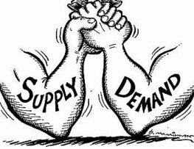
Price | Willingness to Purchase | Class Survey
$2.00

What did you notice related to the class decision?

Is there a pattern? If so, describe it.

What does the data tell us? Why do you think this is so?

For those of you that would not purchase any, why? What does this tell us about other influences on economic decision making?

