Determinants of Demand
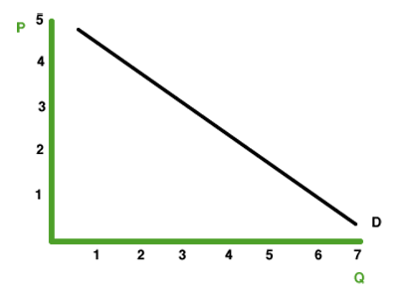
Introduction:
Other than price, what can influence YOU to buy something or not?

Movement along a Demand Curve vs. a Shift of the Curve:
- Remember there is

- Markets never stand still, __________________________________________________________
______________ or how much is demanded altogether.

- A ___________________________________________________________________, other things constant.
This causes a ________________________________________________________.

- A change in one of the determinants of demand causes _________________________________.
This causes a ________________________________________________________.

- Determinants Increasing Demand:
-
-
-
-
-
-
-
- Determinants Decreasing Demand:
-
-
-
-
-
-
-

