Macroeconomics
The Business Cycle and Economic Indicators
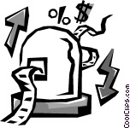

1. What is a business cycle?

2. Recession or Depression?
a. Recession:

B. Depression:

3. Different Impact of the Business Cycle on States:

3. Business Cycles and the Global Economy:

4. What is an Economic Indicator?

5. Types of Economic Indicators:
- Leading:

Examples: ___________________________________
___________________________________
___________________________________
___________________________________
___________________________________
___________________________________
___________________________________
___________________________________

b. Lagging:

Examples: ___________________________________
___________________________________
___________________________________
___________________________________
___________________________________

6. Characteristics of Economic Indicators:
a. Relation to Business Cycle

b. Frequency of Data

c. Timing of Data

