GDP - Notes
Measuring Economic Growth
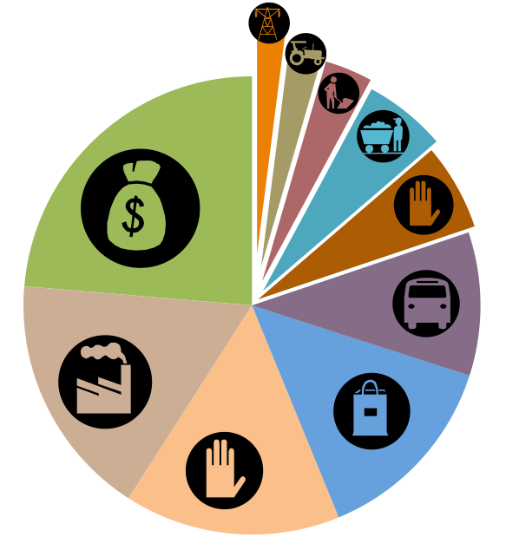

I. Gross Domestic Product (GDP)
Definition
Current/Nominal GDP -

Real GDP

II. GDP is measured by _________________________ spent on ____ categories:
-
-
-
-

- GDP is = to

III. Consumer and Government Spending
Consumer: The spending by _______________________ on __________________ and
_____________________
- Examples:

- Makes up ______% of GDP

Government: Spending by _________________ of government on _____________________
and _______________________.
- Examples:

- ___________% of GDP

IV. Investment
Definition:
- Examples:

- ________ of Total GDP
V. Net Exports
Definition: Spending by the people outside of the United States on ______________________
goods and services (exports or _____) minus _____________________________________
the people of the United States on ________________ goods and services. ( )
- (X-M) = ___________________
- (X)
- (M)

VI. What’s NOT included in the GDP
The GDP includes only _________________ and ________________ that have been
purchased for final use.
NOT Included:
_______________________

_______________________

_______________________

_______________________

_______________________

_______________________

VII. An Alternative to GDP:
GPI ____________________________
- Developed in ____________
- Attempts to measure factors ____________________________________________

- Adds for
-
-

VIII. Genuine Progress Indicator (GPI)
Subtracts for
- __________________________

- __________________________

- __________________________

- __________________________

- __________________________

