Name _____________________

The WHAT???...What I know about the GDP
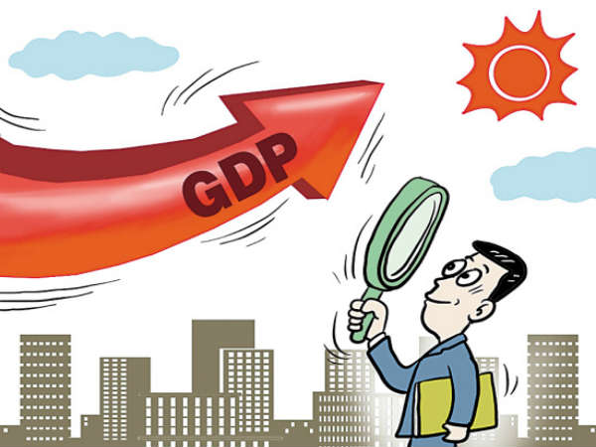

What I know now... | What I know after the reading... | Now look at what I know...

