Key Terms - Taxes and Government Spending #2
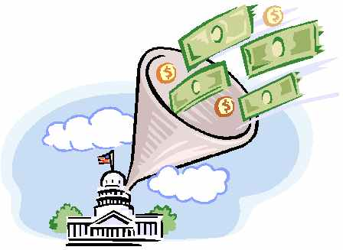
Directions: Define the term, give an example of the concepts, and create a symbol that you feel represents the key term. (page 361)
Term | Definition | Example | Symbol
Proportional Tax
Progressive Tax
Regressive Tax
Social Security

Medicare

Medicaid

mandatory spending

discretionary spending

