Name _____________________
Key Terms Macroeconomics
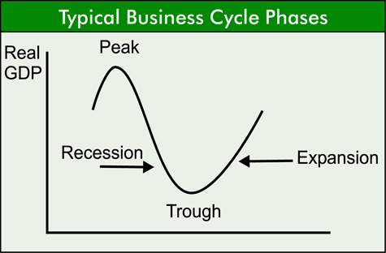

Key Term | Definition | Example | Visual
Macroeconomics

Key Term | Definition | Example | Visual
Business Cycle
Contraction

Expansion
Key Term | Definition
Lagging Economic Indicator
Leading Economic Indicator
Peak
Prosperity
Recession
Recovery

Trough

