Role of Government in Economics - Part 1
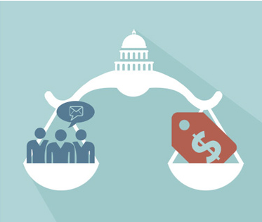
I. Government vs. Economic Systems:
a.

B.

C.

1.

2.

3.

4. How is our government involved in the economy?

5.

6. The ___________________ lists the purposes of government and the
text of _______________________________ of the Constitution grants
specific powers to the federal government
(_________________________) with respect to the ______________________.

