The Basics of Supply
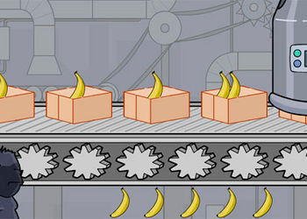

Supply refers to…

The Law of Supply -

Draw the relationship of supply:

Why are price and quantity supplied positively (directly) related?

How We Look at Supply (Draw the Curve)--

Movement along a Supply Curve

Determinants of Supply -
Factors that can shift the supply curve:

