Name _____________________________

The Walt Disney Story

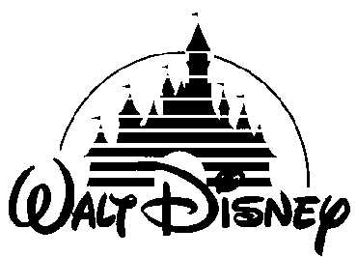
1. What did Walt Disney create in his first drawing?

2. Where did Walt Disney spend his first money made? ___________________________________

3. How did Walt Disney approach the cartoon-making business differently compared to those in the past?

4. What were Walt Disney and his brother Roy the first to do in Hollywood, California?

5. What were some of the original ideas that Walt Disney came up with?

6. How much did Disney spend to build his first large-scale studio? ____________________________

7. Describe how Walt Disney was a risk-taker.

8. Where did the ideas that led to the creation of Disney Parks come from?

9. Why did Walt Disney state that the Disney Parks would NEVER be complete?

