“What’s Counted, What’s Not”
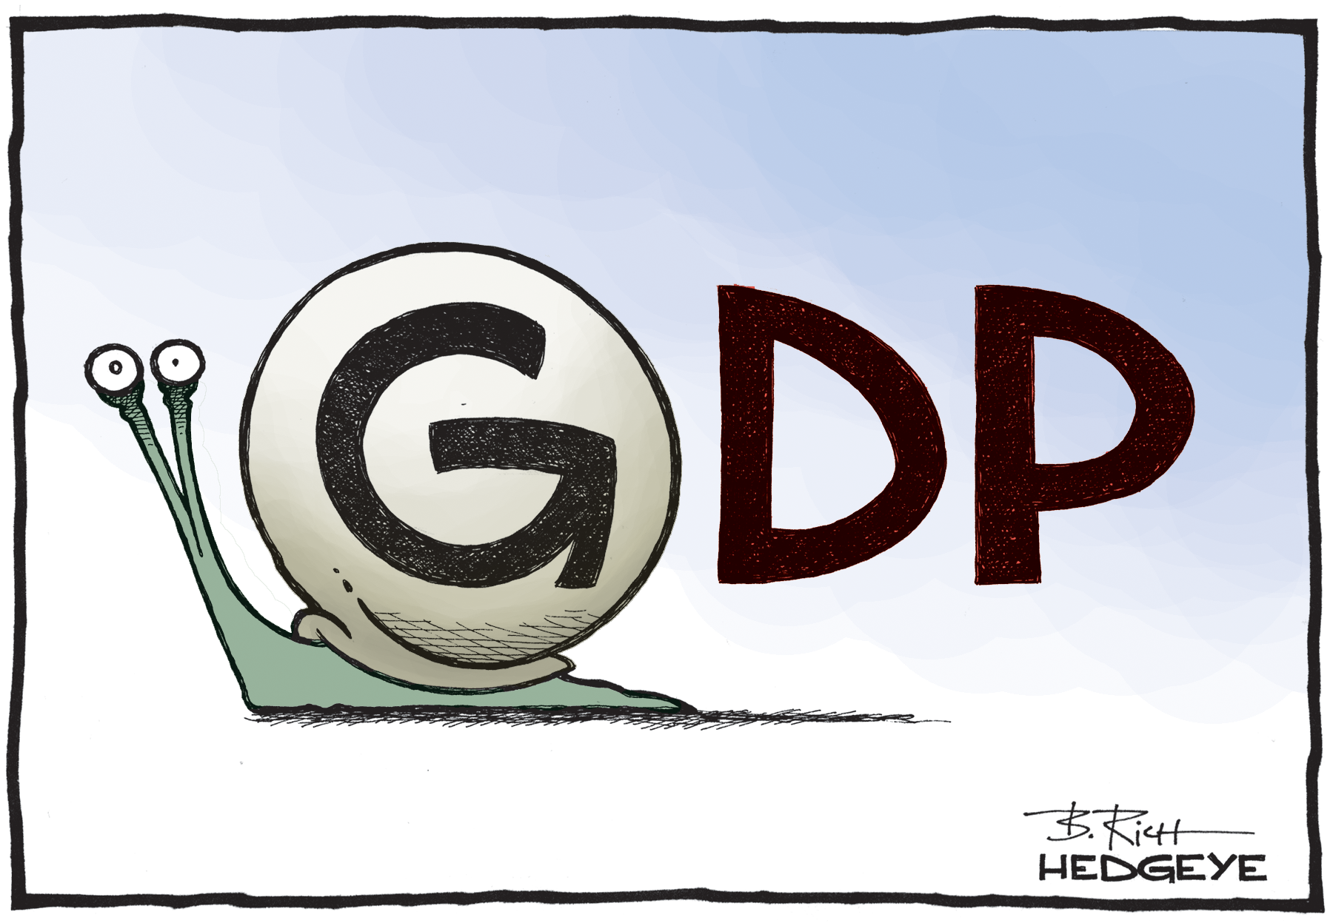

1. Write a summary of the article:

2. What information in the article relates to what we know about the GDP?

3. What new information did you discover from the article?

4. Based on the reading and our study of the GDP, what do YOU feel to be the biggest challenge about getting an accurate dollar value of what is produced in the United States?

